**CASE STUDY**

**(Java Spring Boot Application)**

**Name:** Tanya Singh

**Batch:** 6

**Project Management Setup:**

1. Creating Azure Board including EPIC, Feature, User Story and tasks by giving title and description.

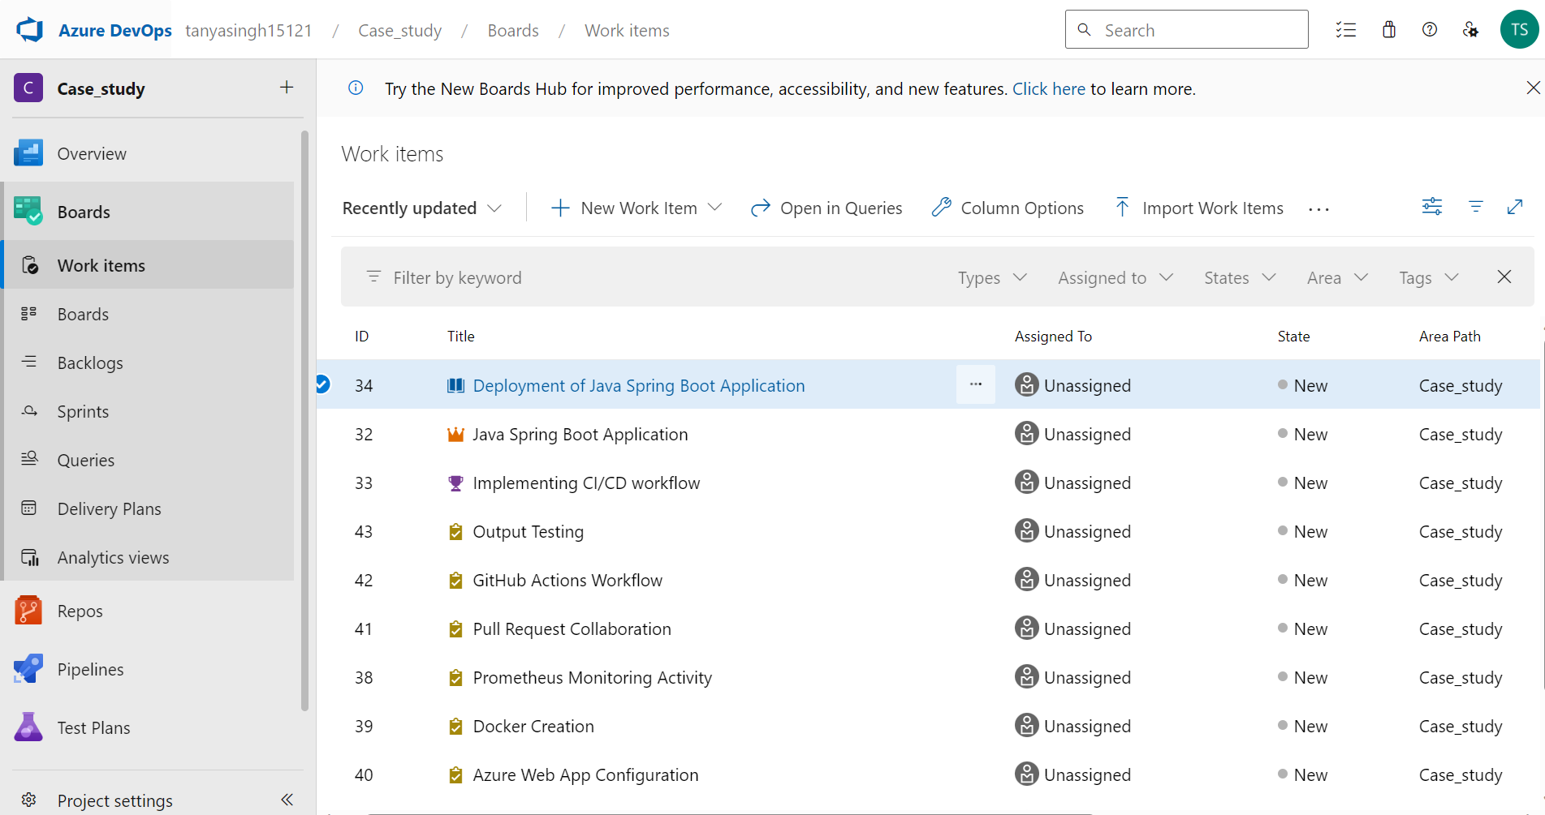

1. Assigning priority and hours to each task.

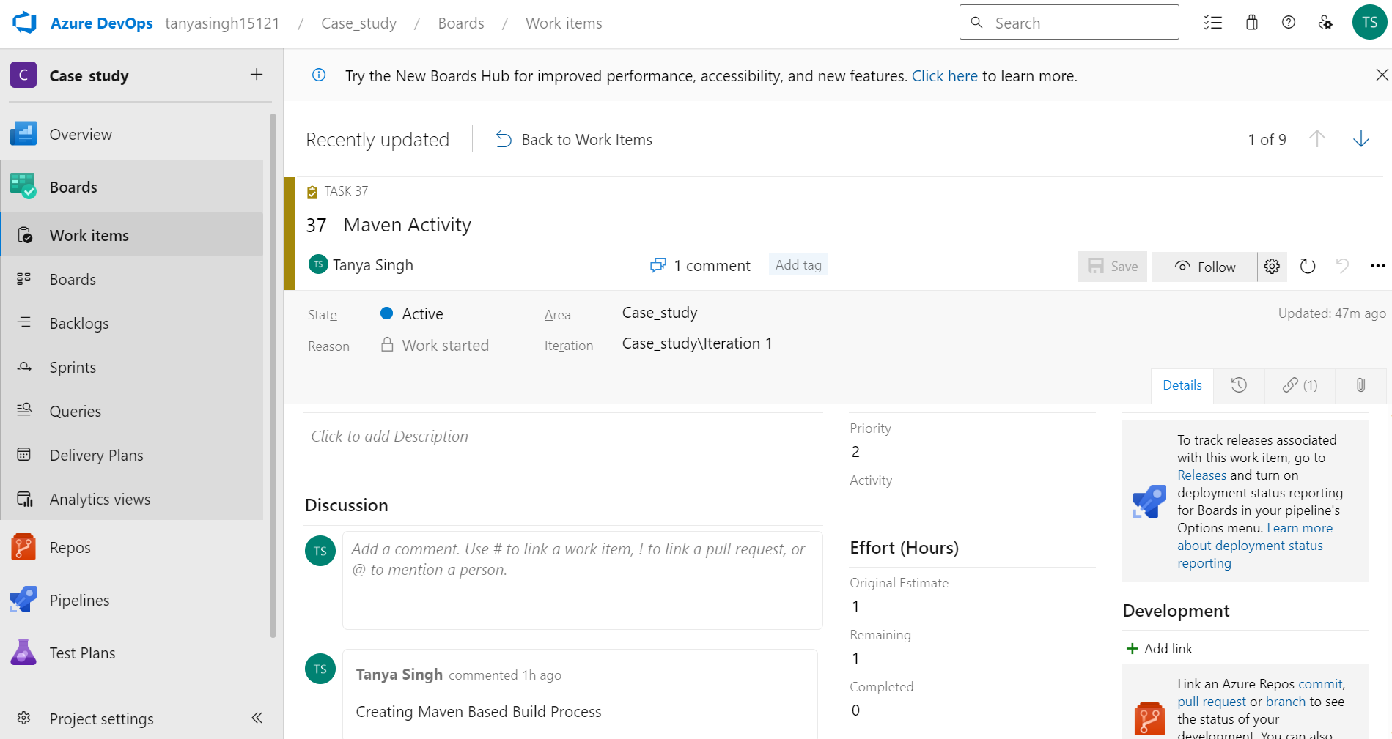

1. Linking the tasks to user story, user story to feature, feature to EPIC.
2. Adding tasks and user story to a sprint.
3. Marking tasks as closed which are done, assigning active state to the tasks which are currently in progress.

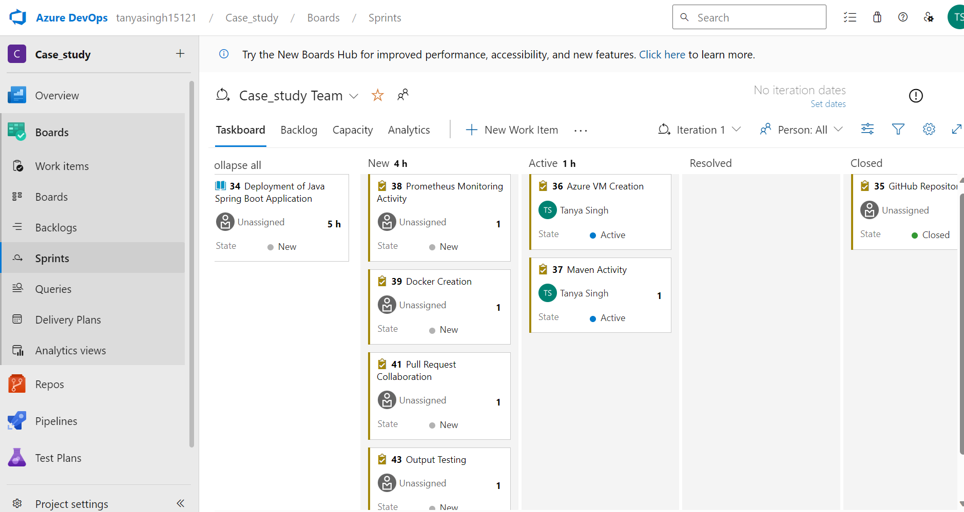

**GitHub Repository and Feature Branching:**

1. Fork the repository to your GitHub account.
2. Create a new feature branch on your forked repository.
3. Clone the main branch code to the new feature branch.

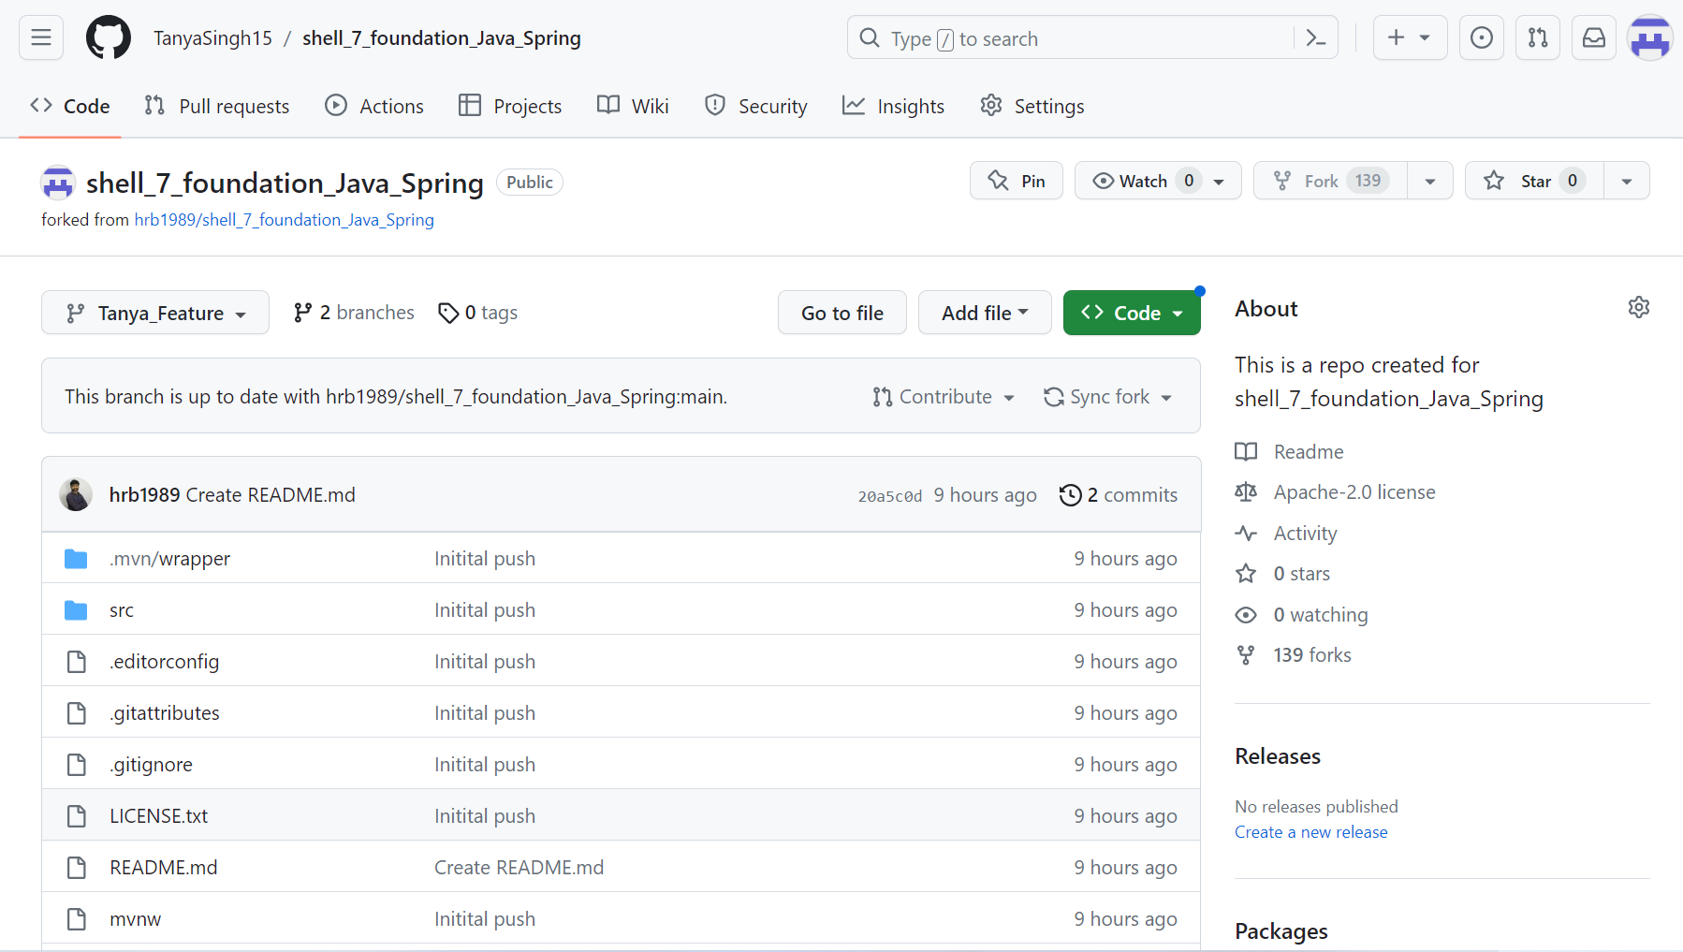

**Azure VM Configuration:**

1. Create Azure VM by giving resource group, username, and password.
2. Connect to the website <https://ssheasy.com/> by giving public IP address, username and password.

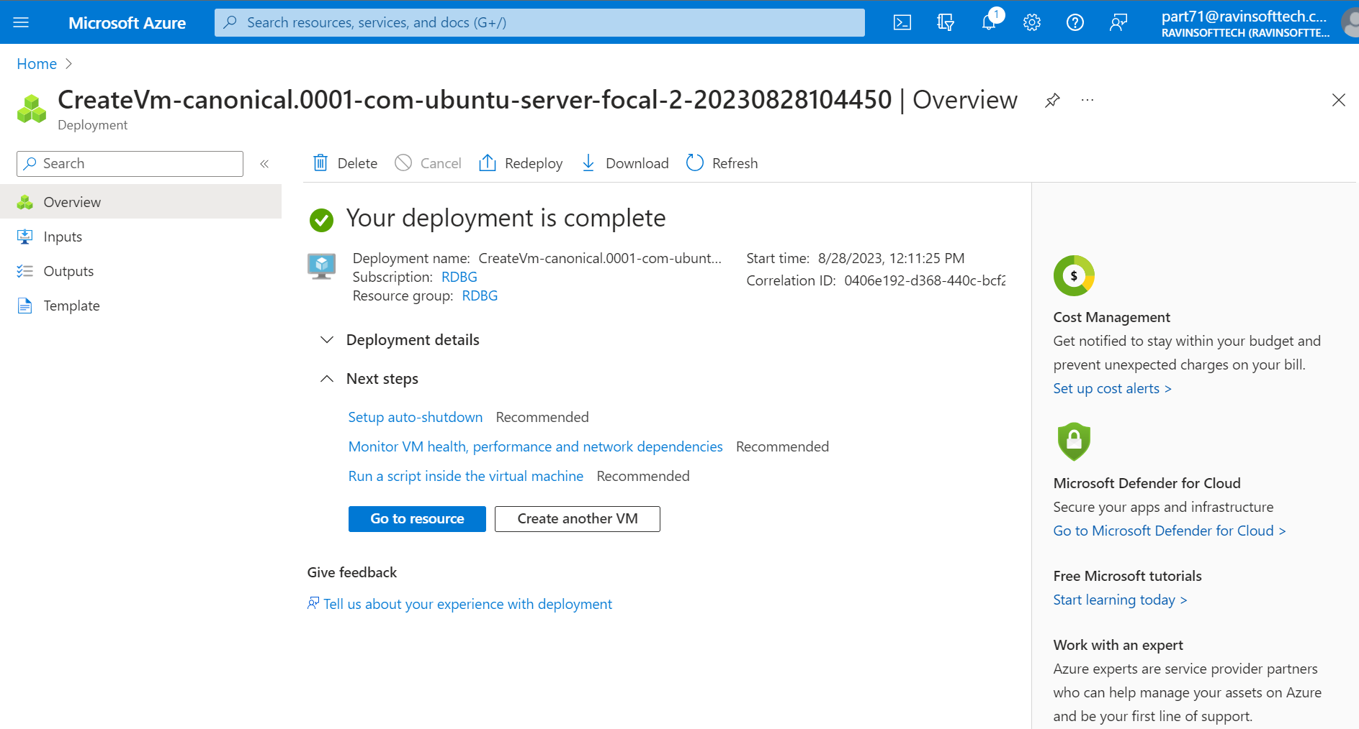

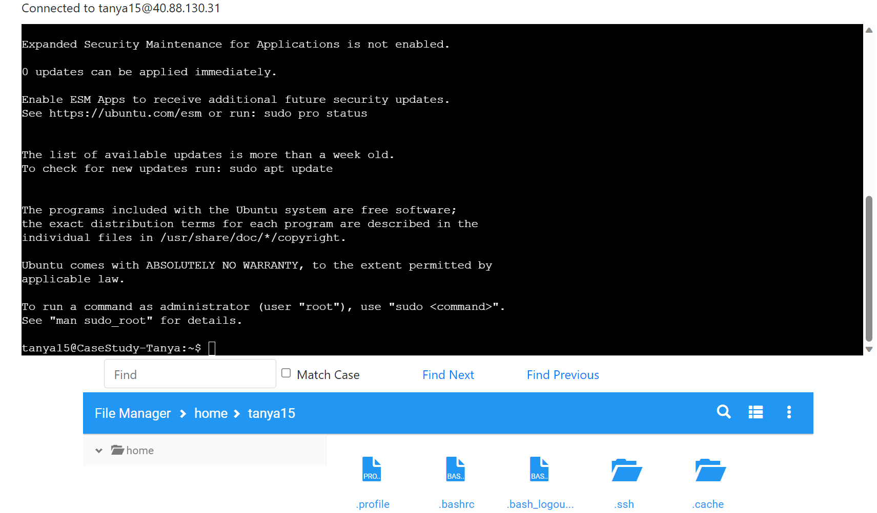

**Maven-Based Build Process:**

1. Installing maven using command “sudo apt install maven”.

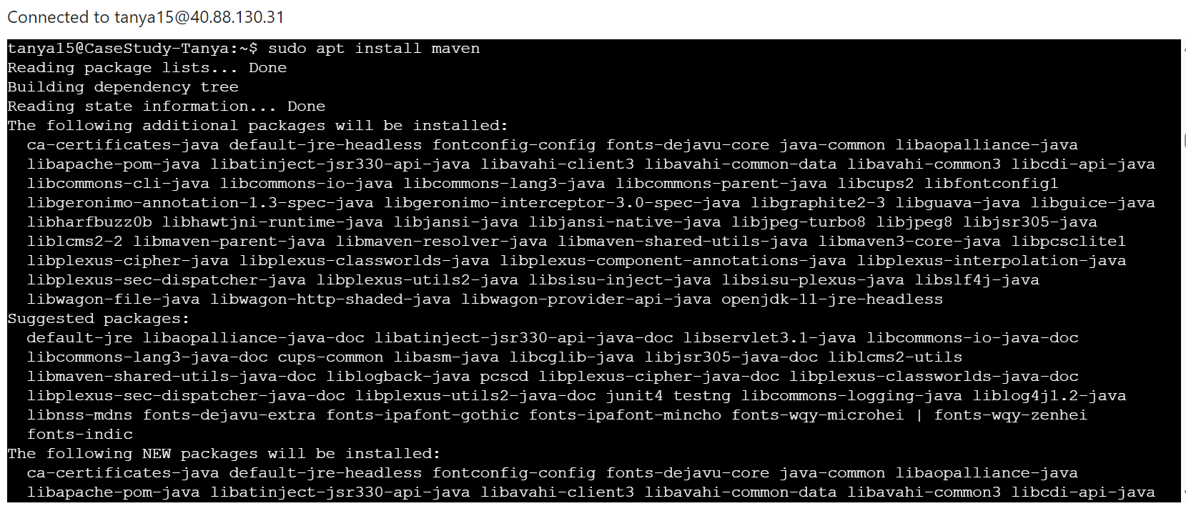

1. Git clone

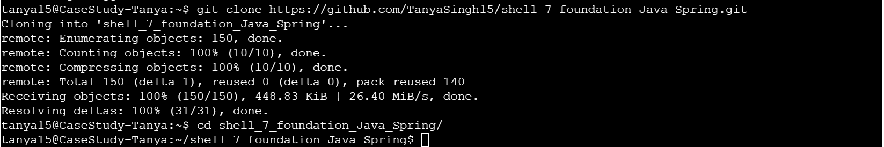

1. Switched to new branch



1. Maven build successfully

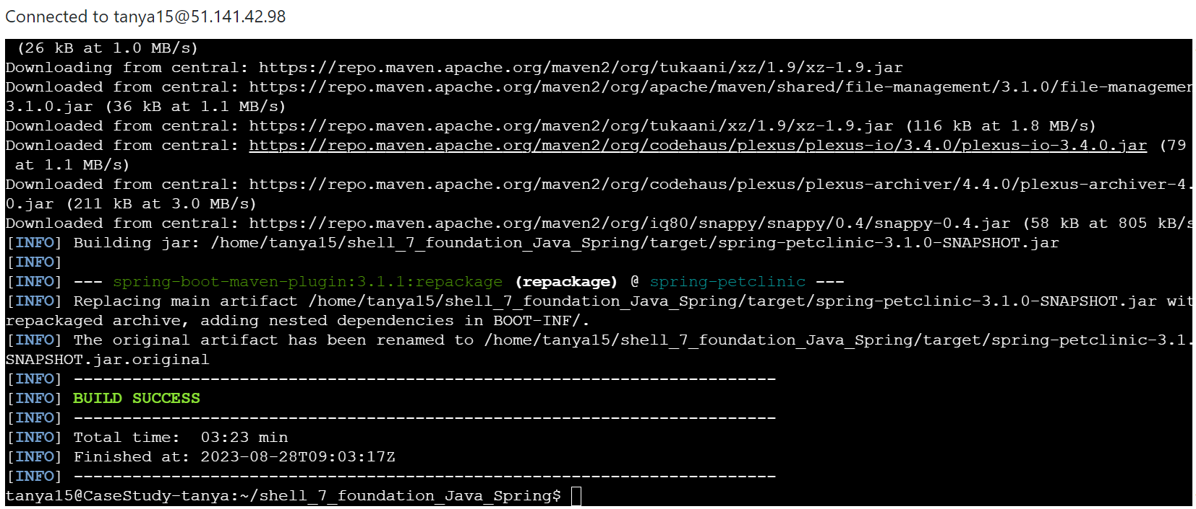

**Prometheus Monitoring Integration:**

1. Installing Prometheus using command “sudo apt install prometheus”.

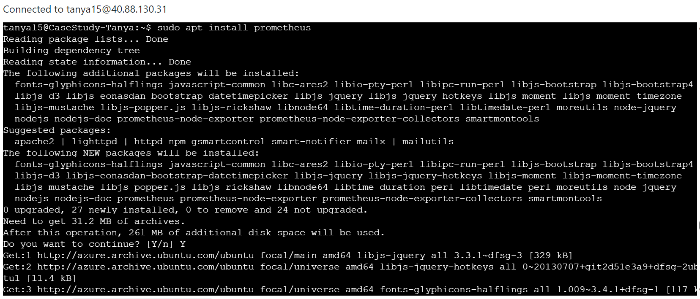

1. Prometheus run successfully

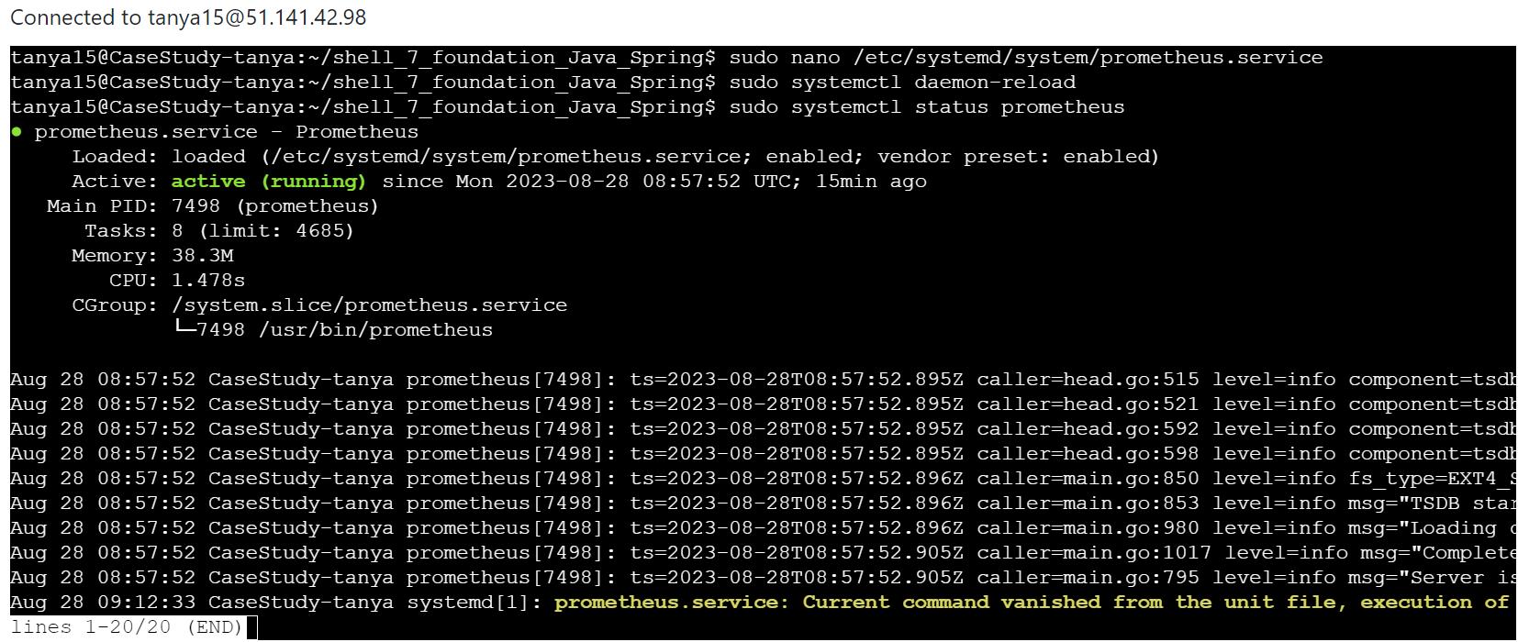

**Docker Containerization:**

1. Installing docker using command “sudo apt install docker.io -y”.

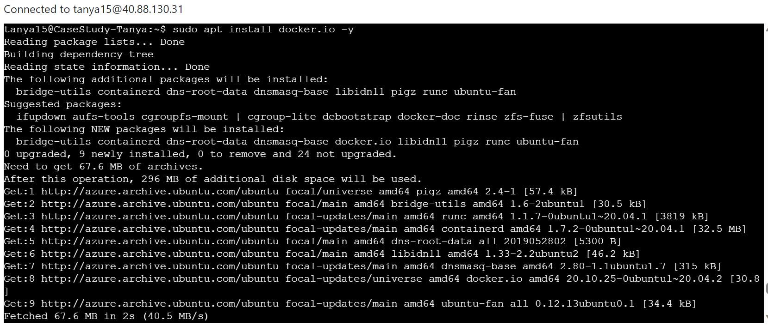

1. Docker build success

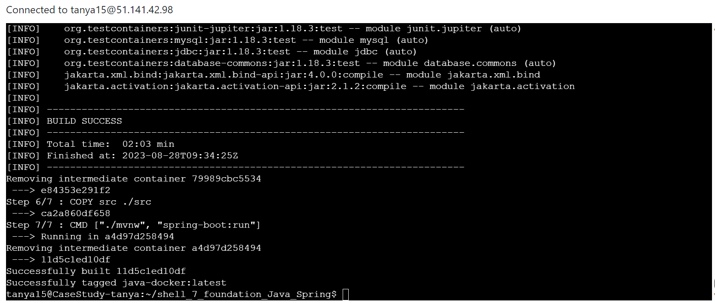

1. Docker images build success

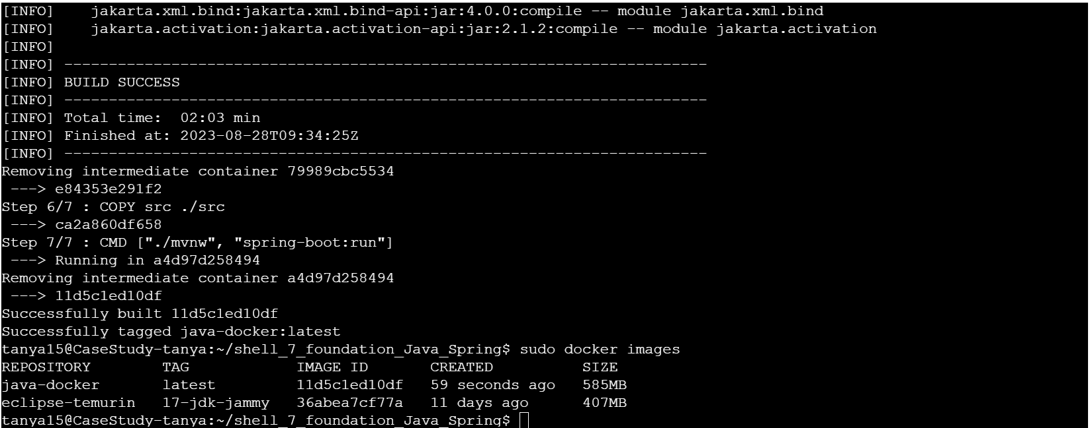

**Pull Request:**

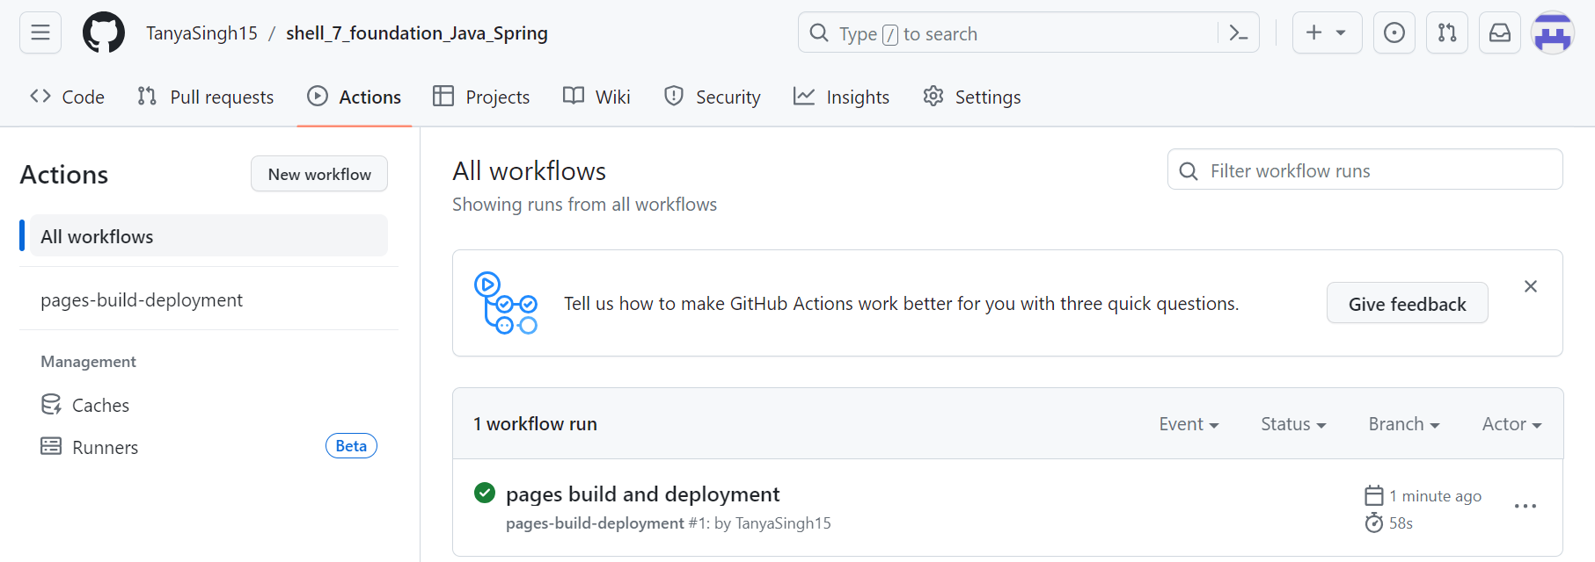

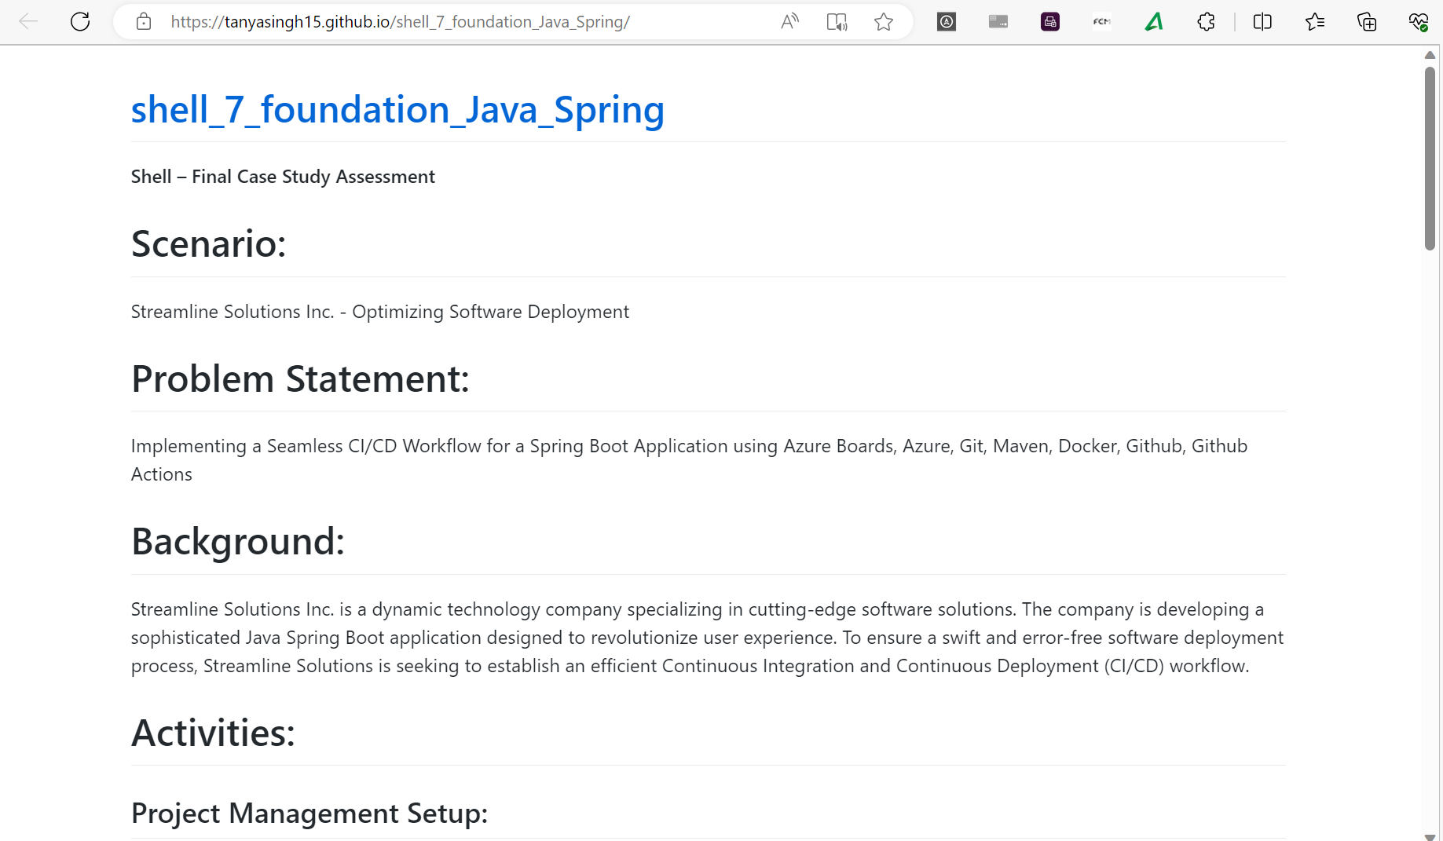

**Azure Web App Configuration:**

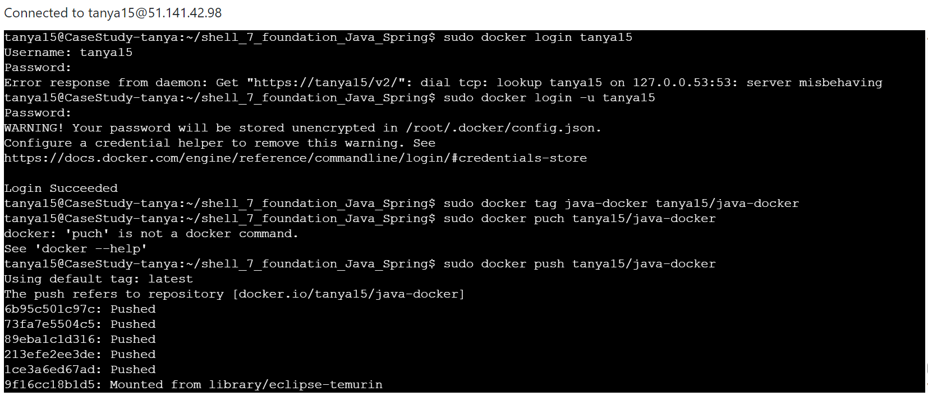

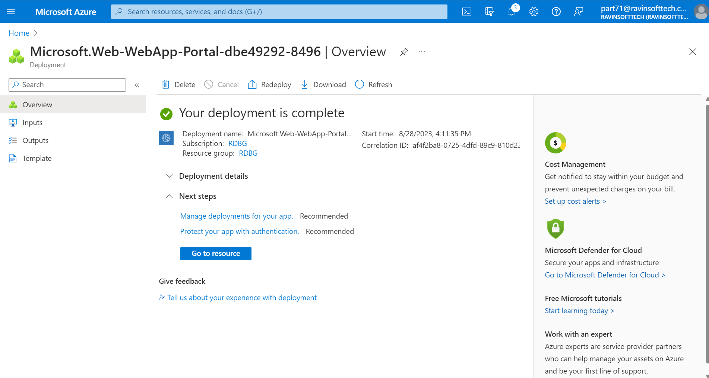

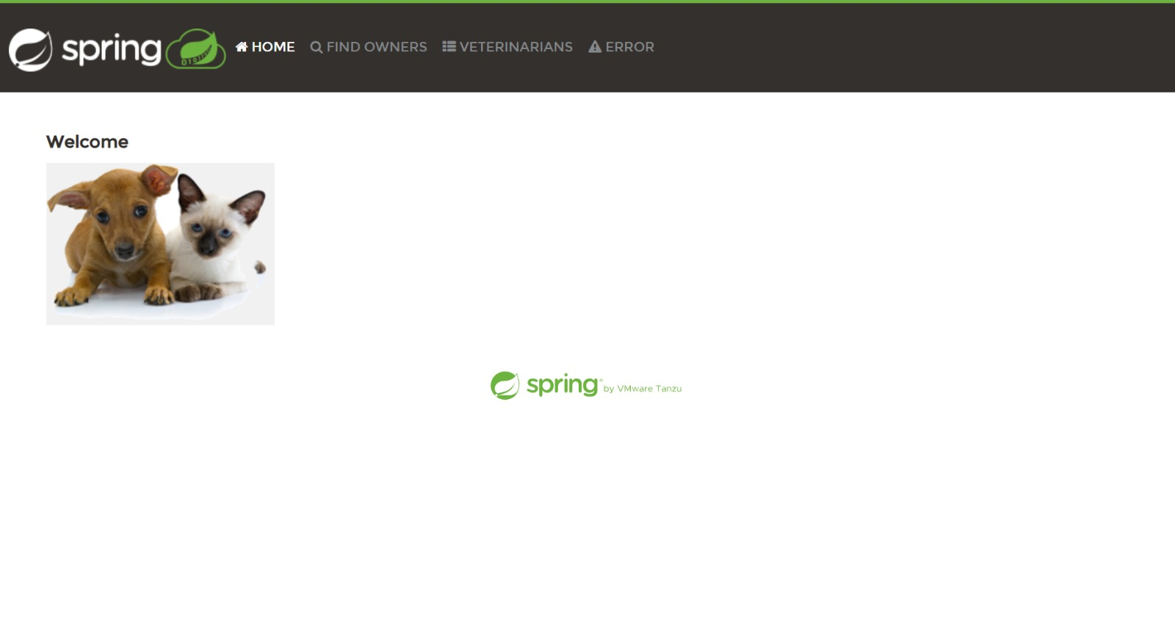

**GitHub Actions Workflow Implementation:**

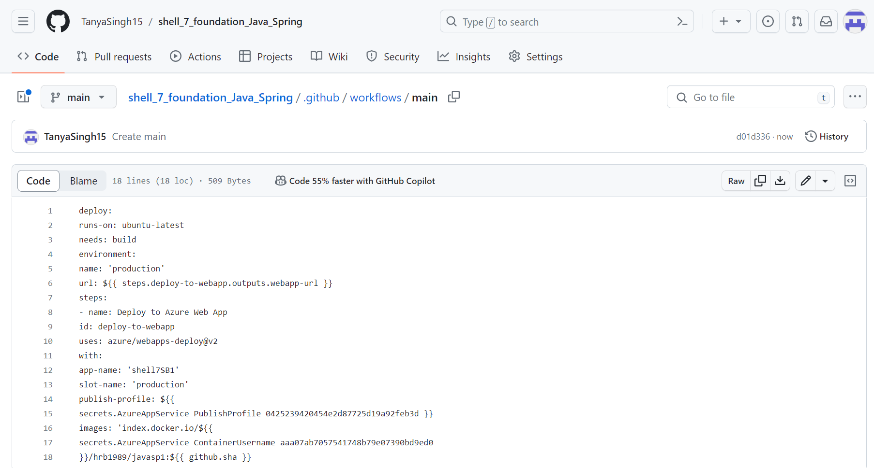

**Test and sprint closure:**

